Lab 4
4. Get the logins name and full names (comment) of logins starts with “g”.
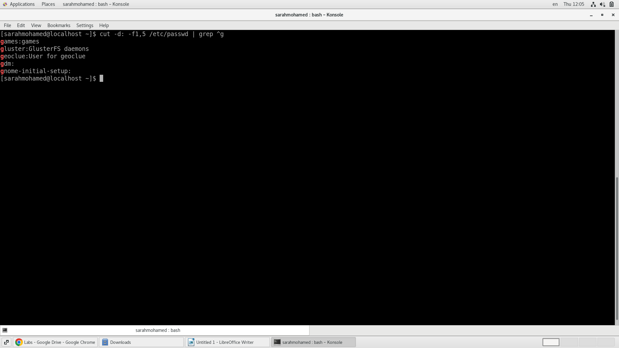
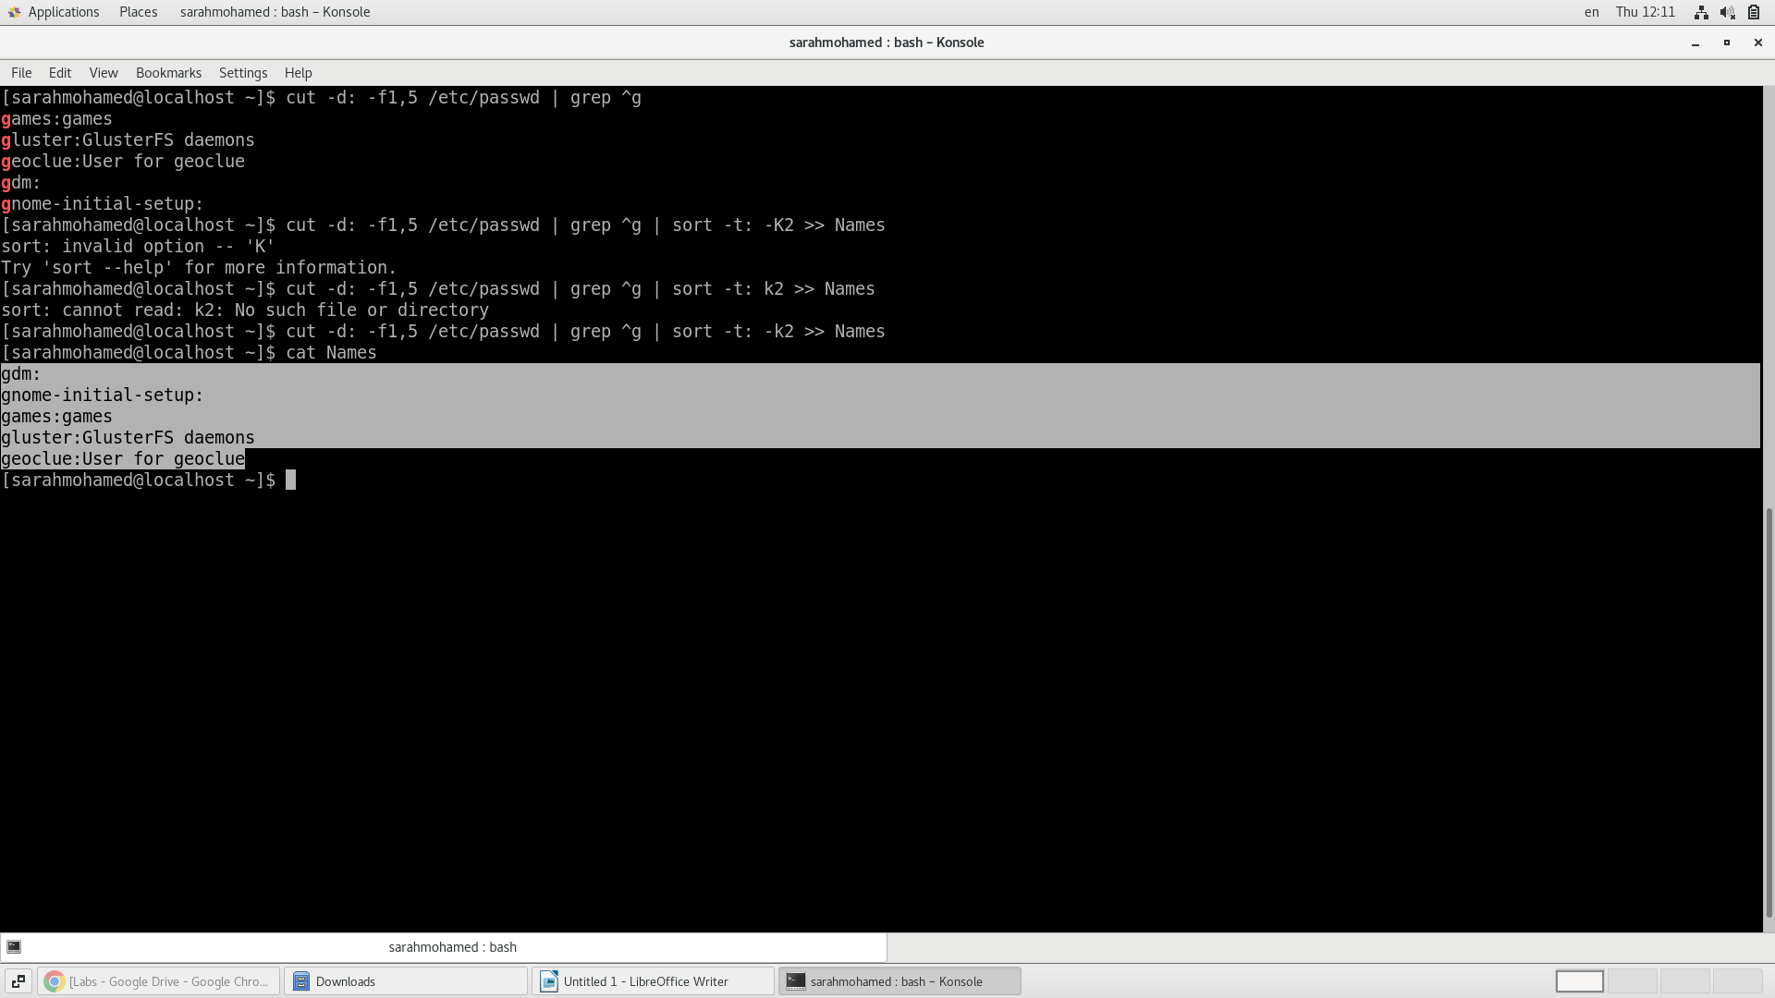
5. Save the output of the last command sorted by their full names in a file.
6. Write two commands:
Second: sorts the output of ls command on / recursively, Saving their output and error in 2 different files and sending them to the background.
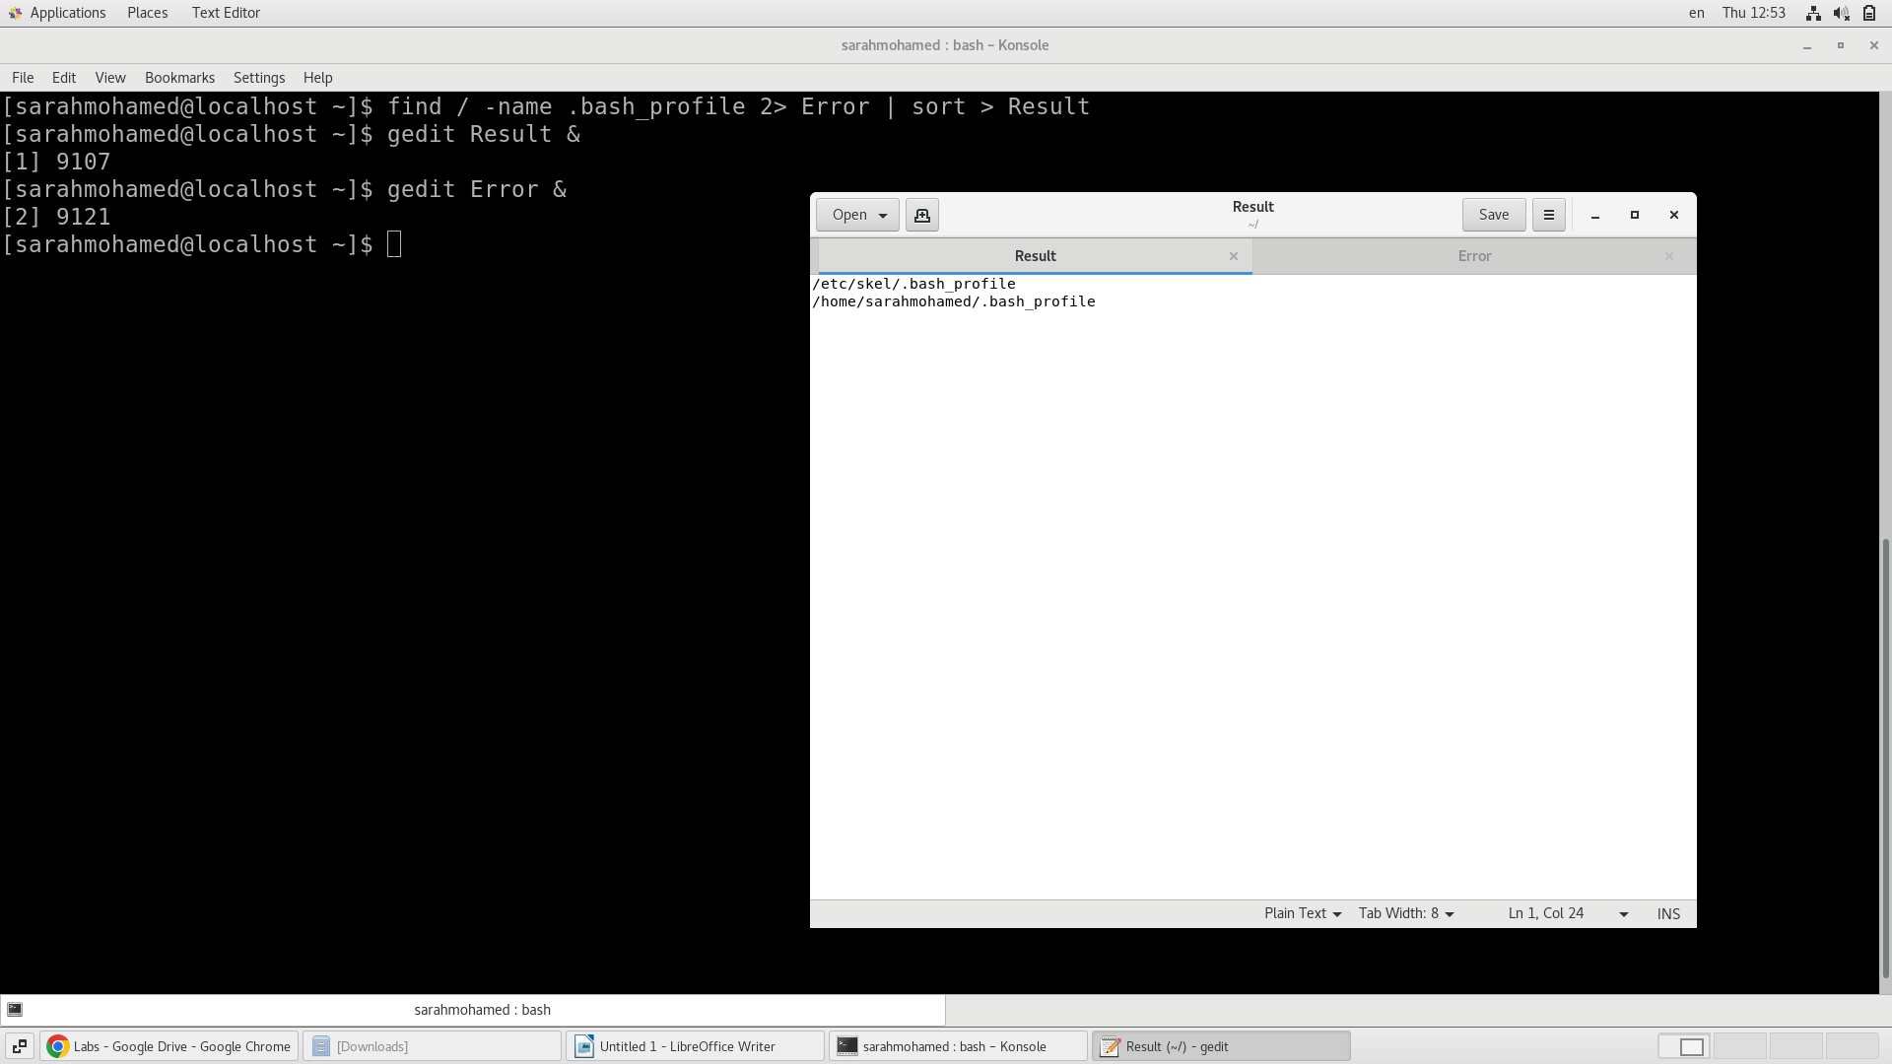

Lab 5
1. Compress a file by compress, gzip, zip commands and decompress it again.
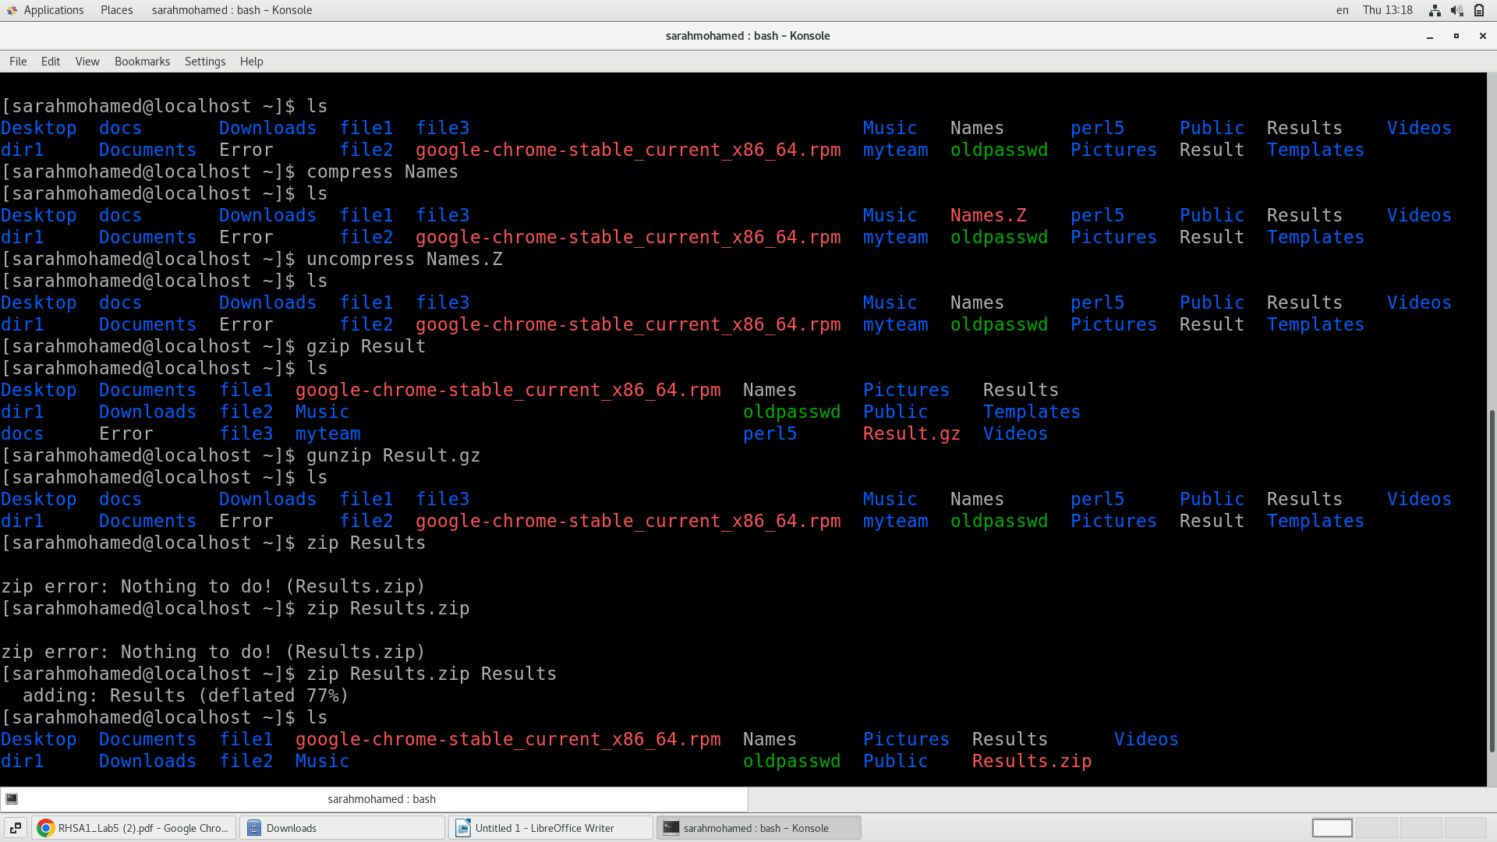
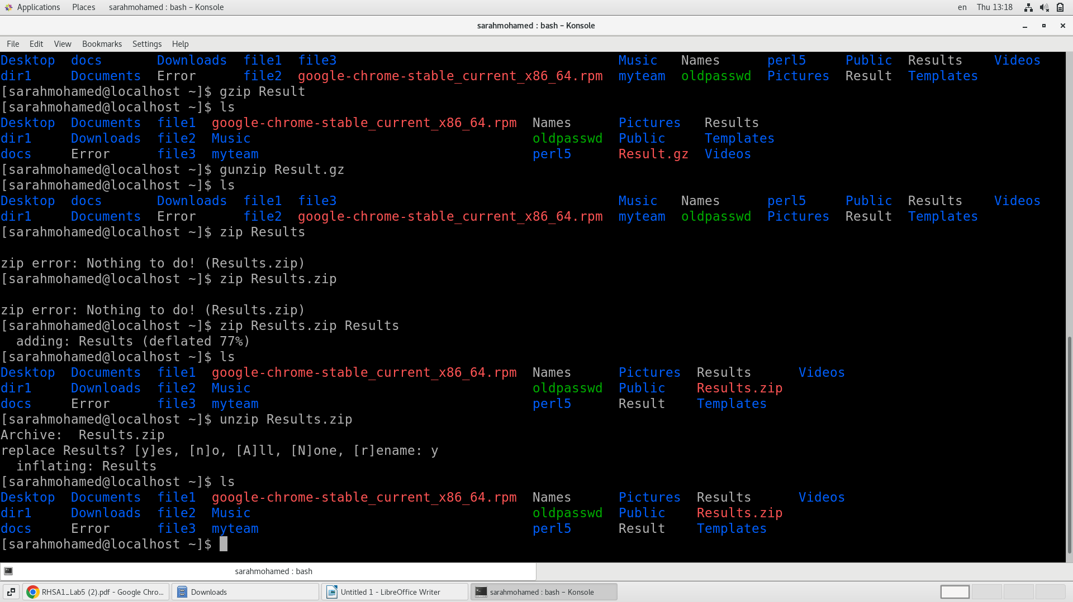

State the differences between compress and gzip commands

=> gzip provides better compression and decompression speeds than compress.

2. What is the command used to view the content of a compressed file.
=> zcat, bzcat

3. Backup /etc directory using tar utility.
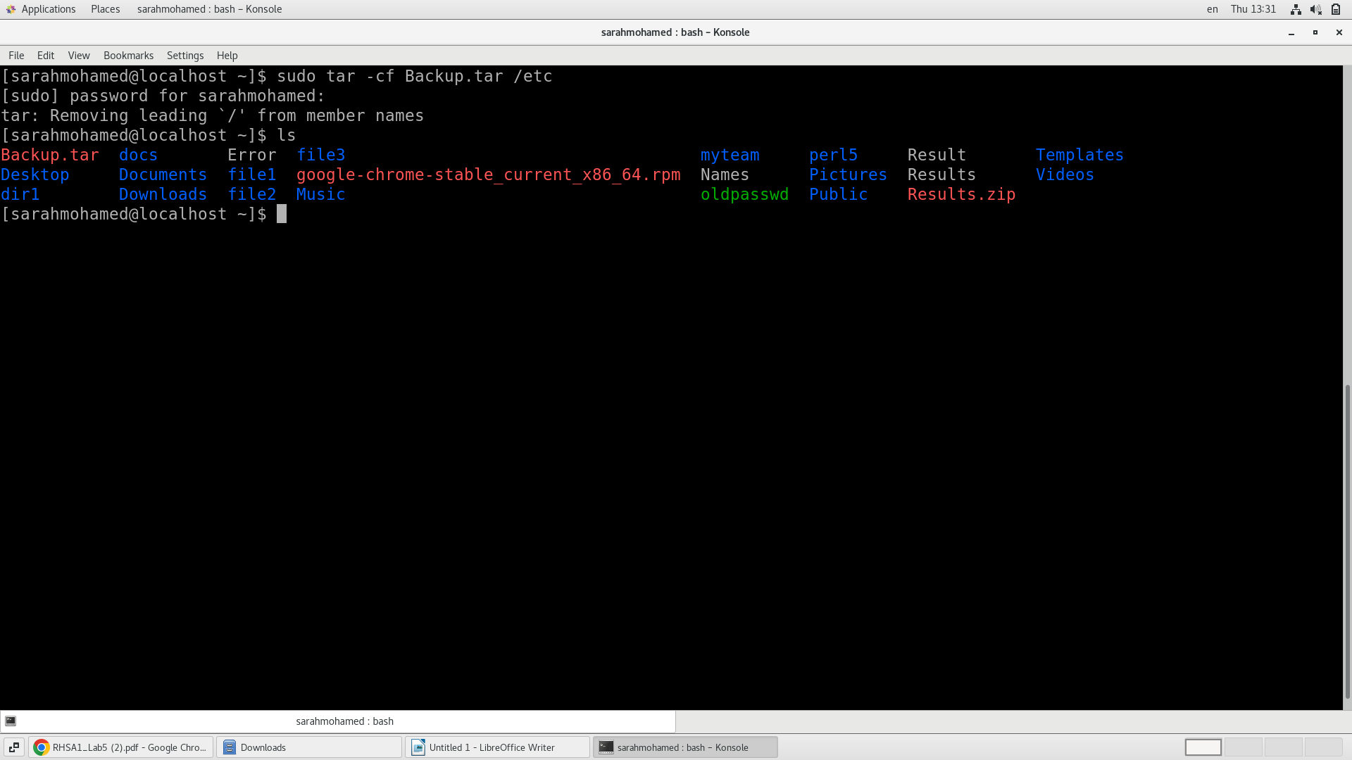

4. Starting from your home directory, find all files that were modified in the last two day.
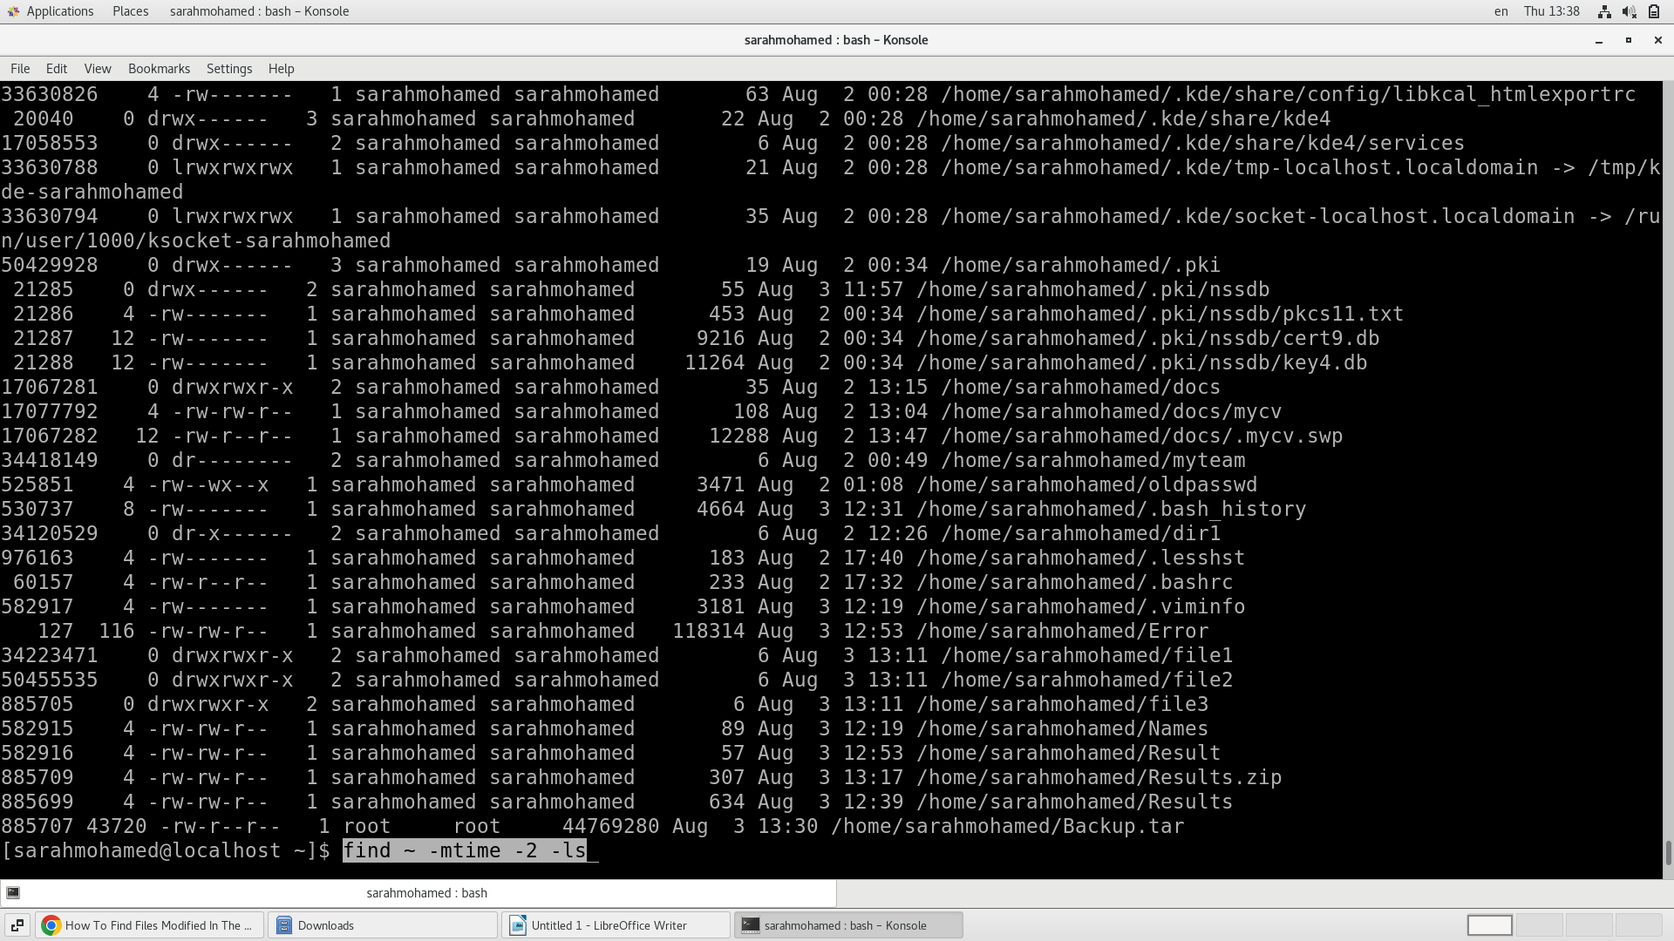
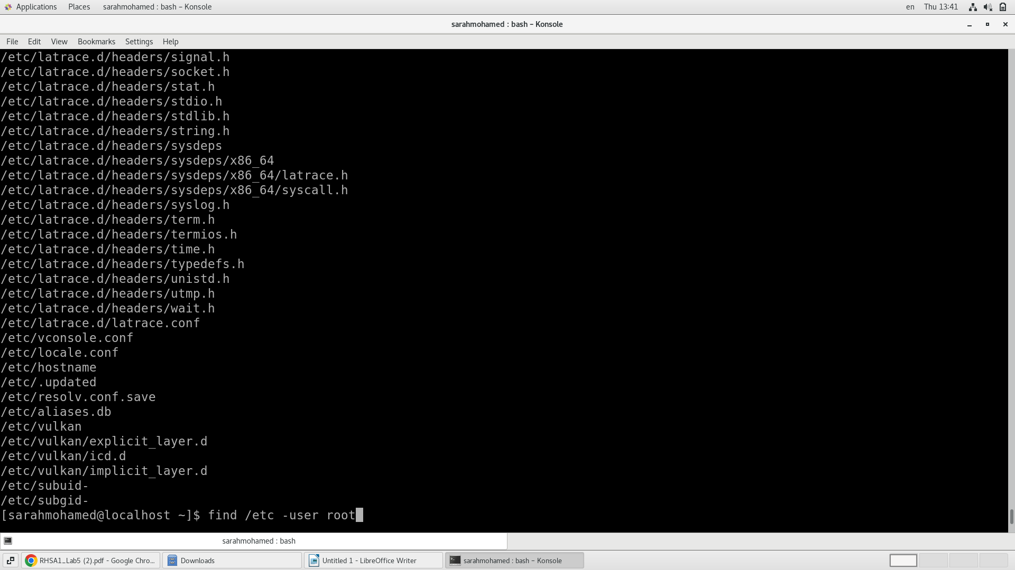
5. Starting from /etc, find files owned by root user.

6. Find all directories in your home directory.
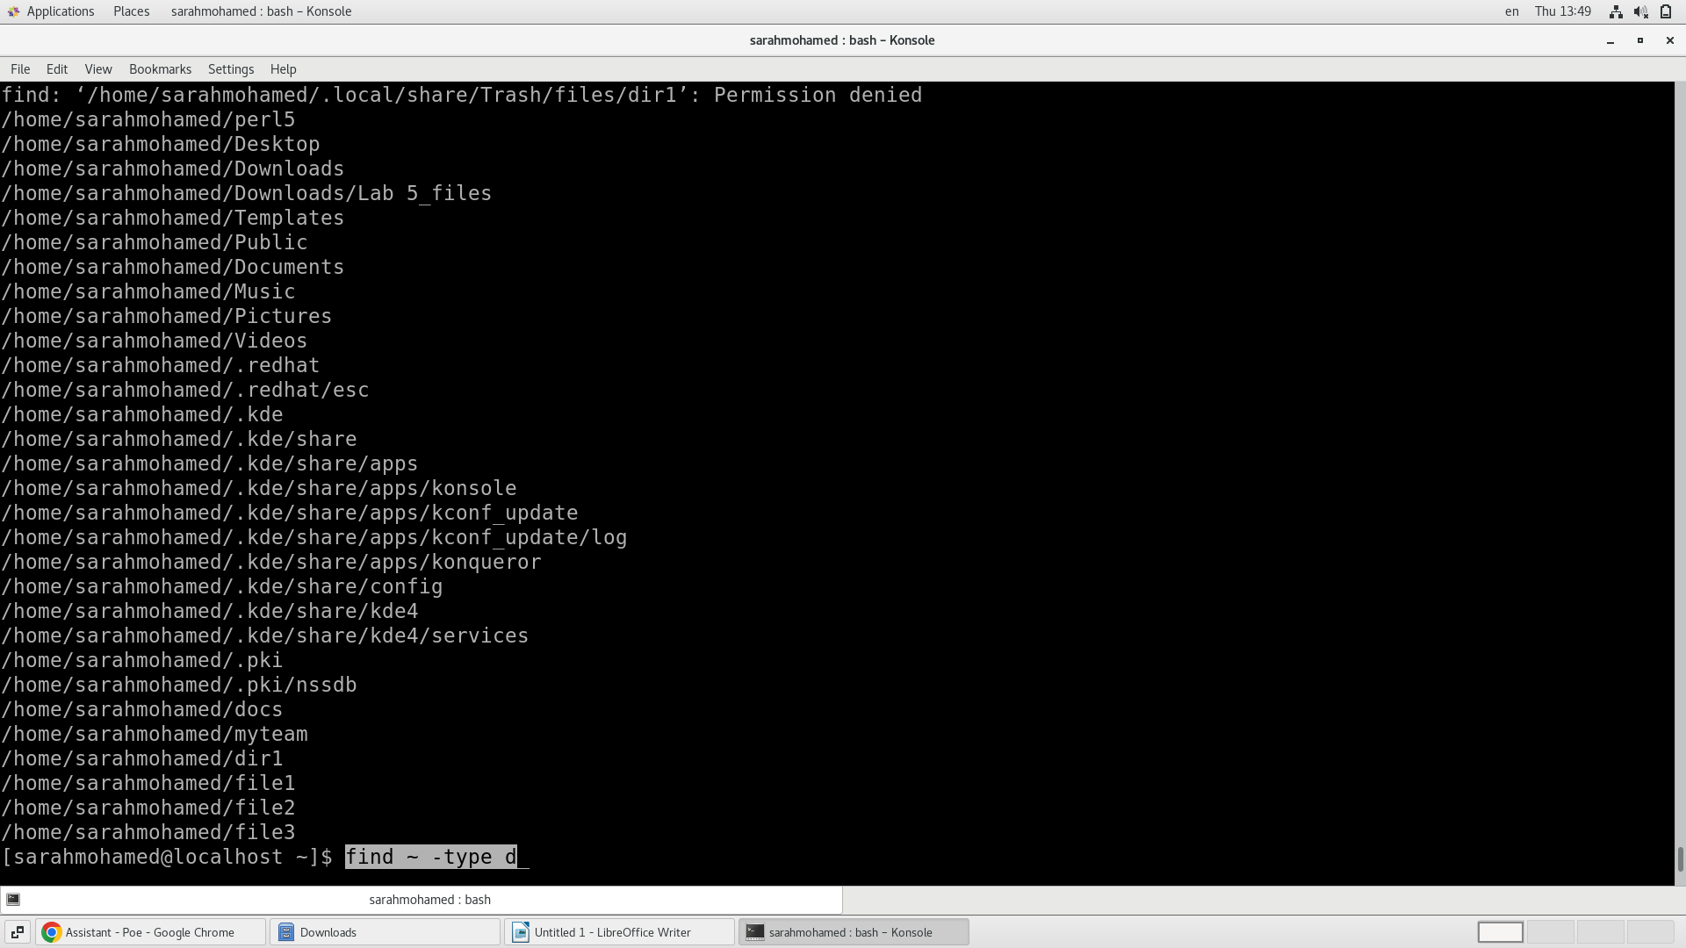
7. Write a command to search for all files on the system that, its name is “.profile”.
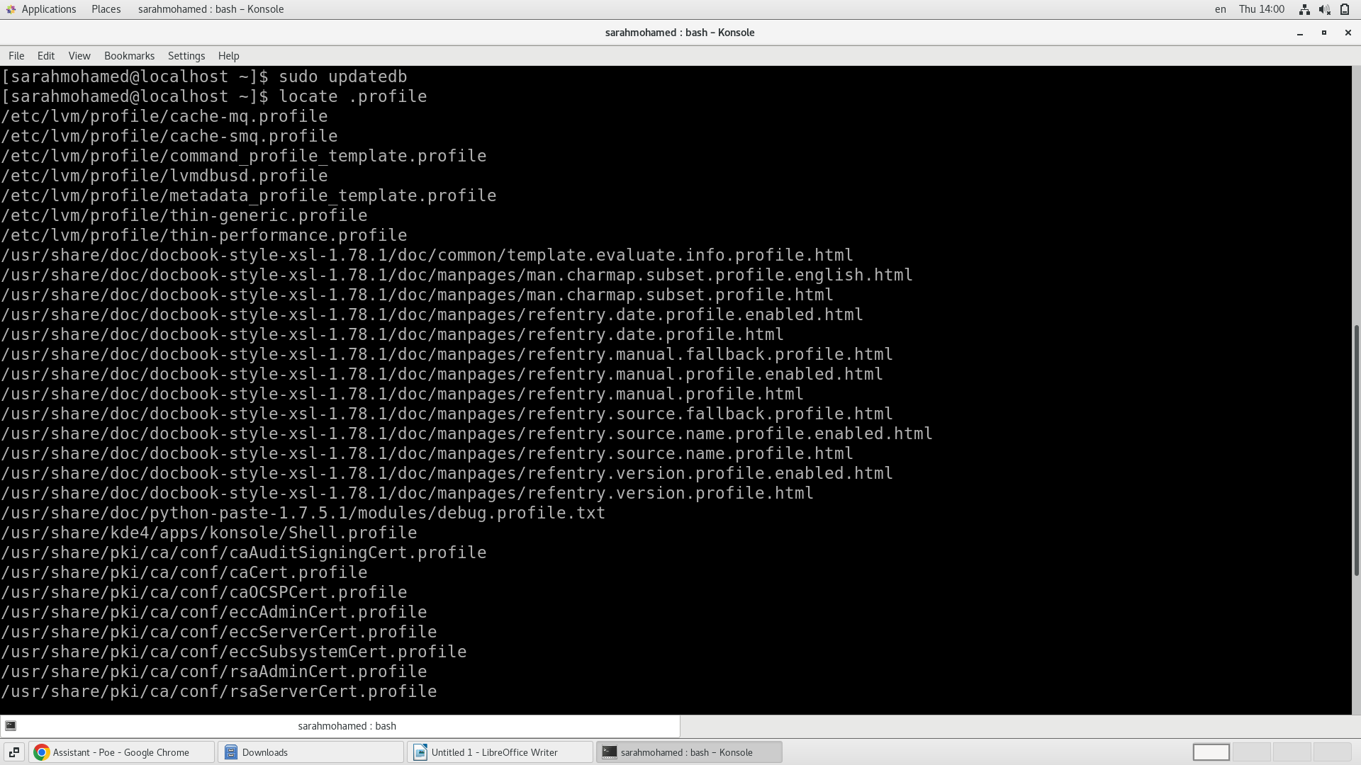
8. Identify the file types of the following: /etc/passwd, /dev/pts/0, /etc, /dev/sda

- /etc/passwd: This is a text file containing information about the system's users and is typically used for authentication.
- /dev/pts/0: This is a character device file representing a terminal.
- /etc: This is a directory containing system configuration files.
- /dev/sda: This is a block device file representing a hard disk drive.

9. List the inode numbers of /, /etc, /etc/hosts

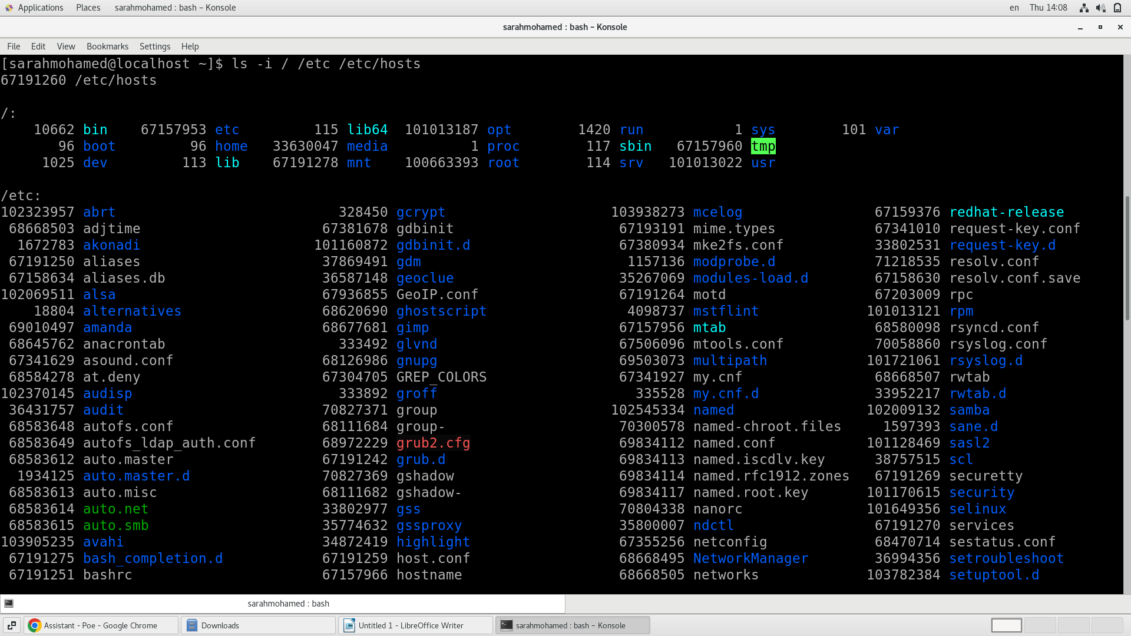

10. Copy /etc/passwd to your home directory, use the commands diff and cmp, and Edit in the file you copied, and then use these commands again, and check the output.
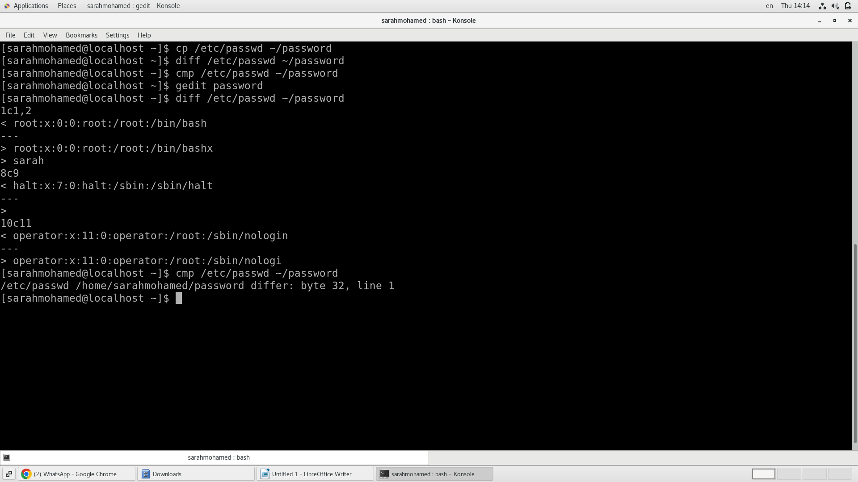

11. Create a symbolic link of /etc/passwd in /boot
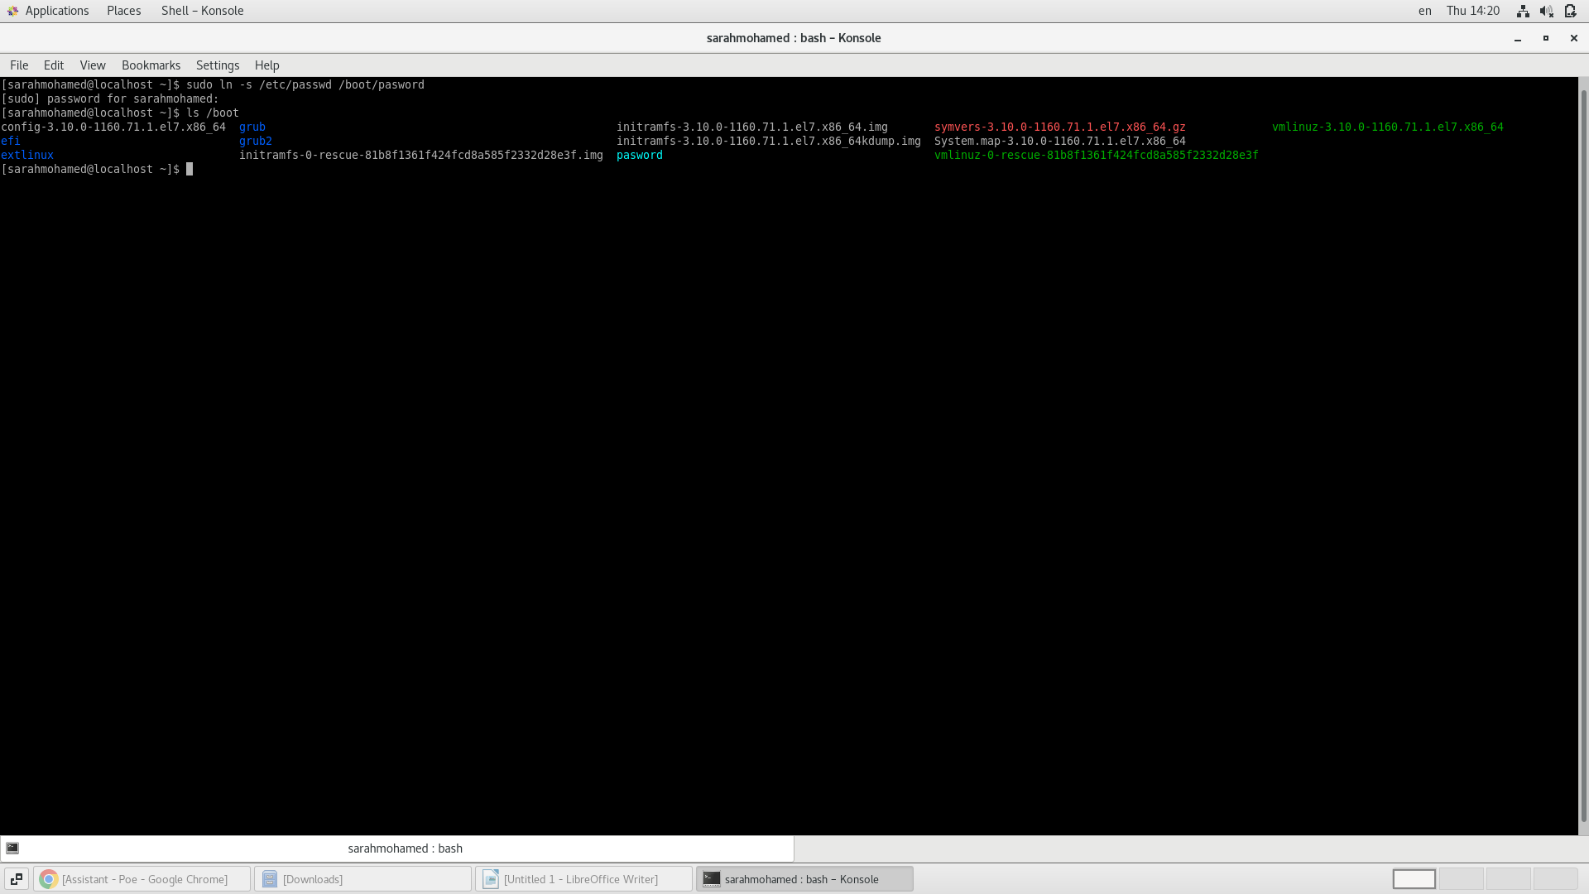
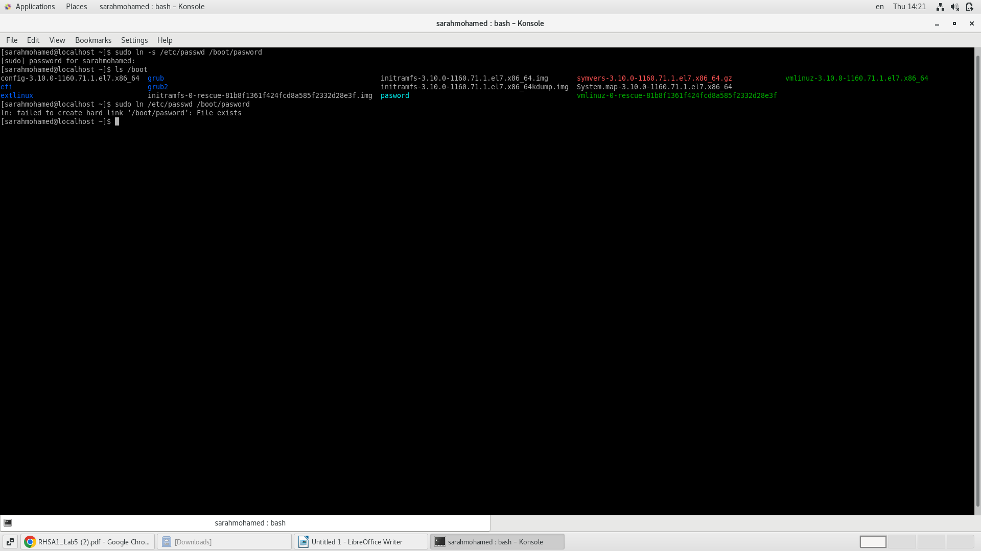
12. Create a hard link of /etc/passwd in /boot. Could you? Why?
I cannot create a hard link of /etc/passwd in the /boot directory because hard links can only be created between files on the same file system, and /etc and /boot are typically on separate file systems.

